- Thursday, March 26, 2020  Native American Cultural Competency  - with Pete Hill (Cayuga, Heron Clan)  - Special Initiatives Coordinator  Native American Community Services  Of Erie and Niagara Counties, Inc.  - 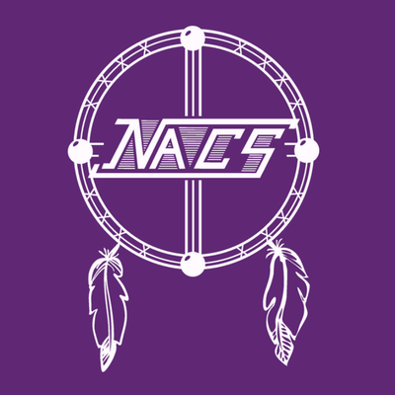  - Working with diverse communities  - Understanding cultural perspectives  - Trauma informed care and the residual impacts of historical trauma and healing efforts  OASAS training certificates will be provided.  There is a $10.00 fee per person *  *Scholarships are available for unpaid staff and unfunded coalition members only. Scholarships need to be requested prior to training.  Please contact Sharon O’Neil if applicable. | Dibble Family Center  4120 W Main Street Rd, Batavia, NY 14020  8:30am Registration 9:00am – 2:30pm Training  12pm Lunch  Register by  March 16, 2020  Sharon O’Neil  soneil@gcasa.org  585-815-1864

Registration Form

Native American Cultural Competency with Pete Hill
  - March 26, 2020

Name:

Agency:

Position:

Phone:

Email address:

Staying for lunch? Dietary Restrictions?

Payment options:

Cash or check.*
Make checks payable to GCASA (Put NACC Training in memo).
If prepaying, mail to:
GCASA
c/o Sharon Koenig
430 E. Main Street
Batavia, NY 14020

*Payment prior to training is encouraged, but will be accepted at the door.

Simply email this registration form by March 16, 2020 to:
Sharon O’Neil, CDS Assistant at soneil@gcasa.org OR by calling 585-815-1864
